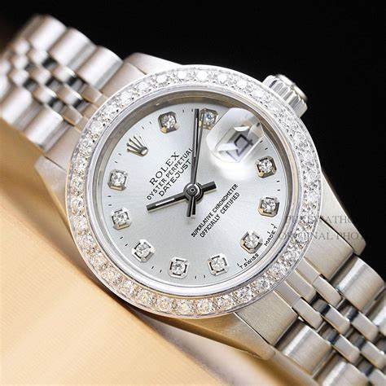ROLEX

DESCRIPTION: Rolex offers a stunning collection of women’s watches that blend luxury, precision, and timeless design. The **Lady-Date just** is the most iconic choice, available in 26mm, 28mm, and 31mm sizes, crafted from materials like Oyster-steel, yellow gold, white gold, Eve rose-gold, and platinum. It features various dial options, diamond settings, and bracelet styles, powered by the reliable Caliber 2236 movement. For those who prefer ultimate luxury, the **Pearl-master** stands out with its exclusive 18k gold construction and dazzling gemstones, available in 34mm and 39mm sizes with an elegant Pearl master bracelet. The **Oyster Perpetual** is a more minimalist yet stylish option, available in sizes from 28mm to 41mm, featuring colorful dials, an Oyster steel case, and a 100m water resistance. For women who love a sporty yet sophisticated look, the **Yacht-Master** in 37mm or 40mm, crafted in Eve rose gold or Orlesian, offers a rotatable bezel and an Oyster-flex rubber bracelet, making it both fashionable and functional. Lastly,